Alice Audiology Website



Colours:
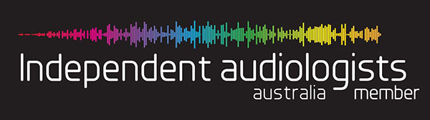



Home Page:
“Experience the world in a new Way”
Change to:
“Hear the world and what matters most”
“Reconnect your life through Sound”
“Where Better Hearing Begins”
Original:
we offer comprehensive assessment, rehabilitation and management of hearing loss, local accessibility and professional, our qualified experience team can help you with your hearing needs.
Change to:
“At Alice Audiology, we combine professional expertise with compassionate care to deliver personalised hearing solutions that help you rediscover the sounds of everyday life.”
“Professional hearing care with a personal touch — helping you hear clearly, communicate confidently, and enjoy life without missing a moment.”

I took this photo from the top of the 20km sand dune just out of town — such a beautiful spot to watch the sunset. 🌅

About
I took this photo from down at Wiggles waterhole Like to sound of the water

About info:
Arafura Audiology was established in 1998 and with Alice Audiology opening in 2011 our permanent clinics ably service the Darwin, Alice Springs, Katherine and Gove Regions. Our highly committed and highly trained Team of hearing care professionals are supported by passionate and caring client services Staff.
We believe the optimal levels of hearing care begin with being able to assess each client, specific needs through expert diagnostic skills.
Proudly independent our clinics prescribe a complete range of audiology services and devices from all hearing aid manufacturers to best suit an individual’s unique hearing requirement and to ensure clients have access to the best hearing solutions.
You can be assured that we offer independent advice and discuss a range of solutions that are best suited to your needs.
Change to:
At Alice Audiology, we are proud to be Alice Springs’ trusted independent hearing clinic, providing personalised and professional hearing care to our local community since 2011.
Located in the heart of Alice Springs, our clinic is dedicated to delivering exceptional hearing services with a genuine focus on compassion, connection, and individual care. We understand that hearing is deeply personal, which is why every client who walks through our doors is treated with the time, respect, and attention they deserve.
Our experienced team of audiologists and client care professionals are passionate about helping people reconnect with the sounds that matter most. Using advanced diagnostic technology and expert clinical knowledge, we provide comprehensive hearing assessments, rehabilitation, hearing aid fittings, and ongoing support tailored to each individual’s lifestyle and hearing needs.
As a proudly independent clinic, we are not limited to one manufacturer. We work with all major hearing aid brands, allowing us to offer unbiased recommendations and customised hearing solutions chosen specifically for you — not for a sales target.
At Alice Audiology, we believe better hearing changes lives. Whether it’s hearing conversations more clearly, reconnecting with loved ones, or simply enjoying everyday moments again, our goal is to help you hear with confidence and live life to the fullest.

Enter your email below to subscribe to our news letter
Email: __________________________________
Submit
Original:
We’ll help you experience the world in a new way.
Book an appointment
Change to:
Supporting you to hear life more clearly and live more confidently.
Book an appointment

Services:
Hearing assessments –
Specialist diagnostic hearing assessment for children and adults including evaluation, management and aftercare. Our experienced clinicians evaluate your complete audiological profile
Change to:
Comprehensive hearing assessments for children and adults, providing expert evaluation, personalised management, and ongoing aftercare. Our experienced clinicians deliver detailed audiological testing to support your hearing health at every stage.
FIND OUT MORE:
- Your hearing health is essential to everyday life, and our experienced clinicians are dedicated to providing thorough, professional care using advanced diagnostic technology. We offer comprehensive hearing assessments alongside specialised services including occupational hearing evaluations, fitness-to-drive assessments, and CASA aviation audiological testing.
Hearing Services Program
- The Australian Government Hearing Services Program provides eligible Australians with access to quality hearing care and support services designed to improve hearing health and quality of life. Administered by the Office of Hearing Services, the program offers a range of funded hearing solutions and services. Contact our clinic or explore the link below to find out more about eligibility and available benefits.
Specialist Services –
Our team of hearing care professionals have expertise in a range of specialist services including tinnitus management balance disorders, auditory Processing, industrial noise management, hearing monitoring and custom hearing protection
Change to:
Our experienced hearing care professionals provide a wide range of specialist services, including tinnitus management, balance disorder assessments, auditory processing evaluations, industrial noise management, hearing monitoring, and custom hearing protection solutions.
FIND OUT MORE:
Tinnitus Management
Tinnitus, commonly experienced as ringing, buzzing, or noise in the ears or head, is a highly individual condition that requires specialised care. Our clinicians provide comprehensive tinnitus assessments and personalised management strategies designed to identify the cause, reduce the impact of symptoms, and support your long-term hearing wellbeing.
Balance Testing -
Your ears do more than help you hear — they play a crucial role in balance, movement, and spatial awareness. When the delicate balance system within the inner ear is affected, symptoms such as dizziness, vertigo, and imbalance can significantly impact daily life. Our specialised balance assessment and treatment services combine advanced diagnostic technology with expert clinical care to accurately identify the cause and deliver personalised solutions to help you regain confidence, stability, and control.
Wax Management -
Clear hearing starts with healthy ears. Excess or impacted ear wax can cause hearing difficulties, discomfort, pressure, and irritation. Our clinic provides professional ear wax removal using advanced microscope-guided microsuction technology — a gentle, precise, and highly effective method designed for maximum comfort and safety. As the only independent audiology clinic in Alice Springs offering this specialised service, we are proud to deliver expert care with exceptional results.

Hearing Aids –
We offer fully independent guidance, choice and selection of hearing aids. We are proudly independent and deal with all major hearing instrument manufacturer. Our services include fitting, follow up and aftercare to assist with your hearing journey.
Change to:
As an independent hearing care provider, we offer unbiased advice and access to a wide range of hearing aids from leading manufacturers. From expert fittings to ongoing support and personalised aftercare, we are committed to helping you hear with confidence every step of the way.
FIND OUT MORE:
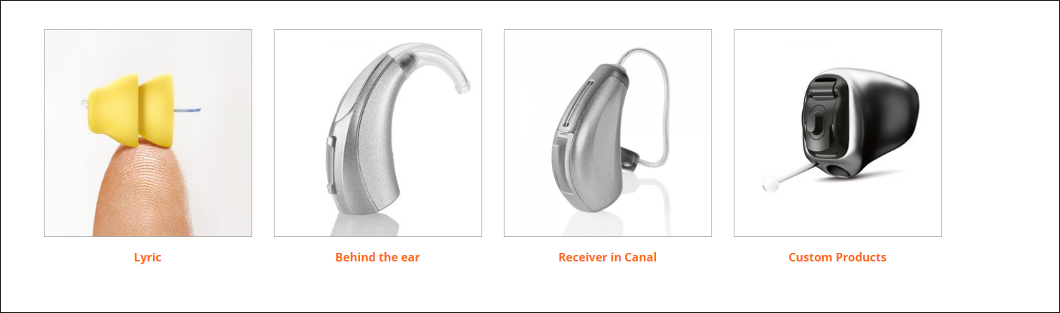
Our hearing aid services are designed to provide truly independent advice, giving you access to a wide range of hearing and listening devices from leading suppliers across Australia. From personalised selection and precise fitting to fine tuning, reviews, and ongoing support, we are committed to ensuring your devices are comfortable, effective, and tailored to your lifestyle every step of the way.

Lyric Premier Certified Clinic -
Lyric is the world’s first completely invisible hearing device, redefining the hearing experience through ground-breaking technology and effortless convenience. Designed to be worn continuously for months at a time, Lyric requires no daily handling or battery changes and can remain comfortably in the ear while showering, sleeping, exercising, and throughout everyday life.
Much like contact lenses transformed vision correction, Lyric has revolutionised hearing care — delivering clear, natural sound in a device so discreet it is virtually invisible. Elegant, seamless, and remarkably easy to live with, Lyric allows wearers to reconnect with the sounds of life with confidence and freedom.
Assistive Listening Devices -
Wireless accessories transform the way you experience sound, bringing the moments that matter into crystal-clear focus while minimising unwanted background noise. Designed to work seamlessly with a wide range of hearing aid styles, these innovative assistive listening devices create effortless connections between you and the technology you use every day — including phones, televisions, music players, computers, and more.
Whether you are taking a call, streaming your favourite show, or enjoying music with exceptional clarity, wireless accessories deliver a richer, more immersive listening experience. Smart, discreet, and incredibly easy to use, they empower you to stay connected, engaged, and fully present in every conversation and every moment.
Blog -
Please share your ideas!!
Rediscovering the moments that matter.
“Sometimes the smallest sounds hold the biggest meaning — the laughter of grandchildren, birds singing early in the morning, quiet conversations with loved ones, or the sound of rain on the roof after a long day. Hearing connects us not only to the world around us, but to the moments that make life feel full. Many people don’t realise how gradually hearing can change, often adapting without noticing what they may be missing. Seeking help for your hearing is not about ageing; it’s about staying connected, confident, and present in the moments that matter most.”

Contact
Phone: (08) 8952 3110
Address: Level 1,8 Gregory Terrace Alice Springs, NT 0870
Email: reception@aliceaudiology.com.au / mc@aliceaudiology.com.au

ADDITIONAL IDEAS
Meet the Team
- Images of Matt, Kat, Danni, Christa
- Some interesting information about each of us
- Testimonials – I have created a word doc we can get a few clients to fill out.

